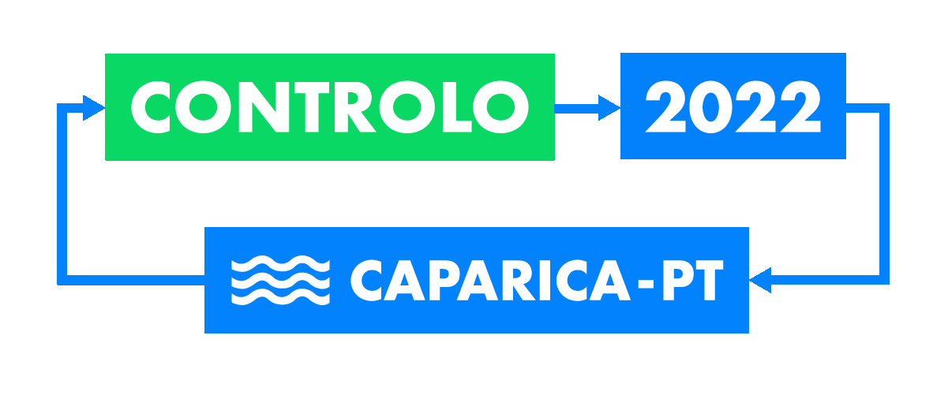
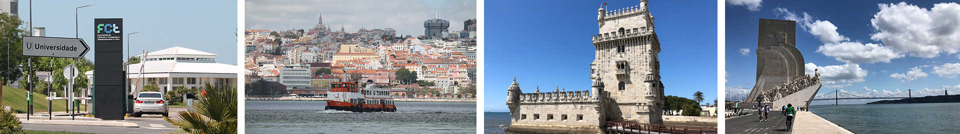
CONTROLO’2022

15th APCA International Conference on Automatic Control and Soft Computing

July 6-8, 2022, Caparica, Lisbon Region, Portugal

https://controlo2022.deec.fct.unl.pt/

Special Session on
“title of the SS”

Organized by
Organizer(s): (Names with affiliation)

Call for Papers
Brief description of the theme:
(approximately 120 words).
Topics of interest include, but are not limited to:
A list of 5-10 special areas.

Previous page (maximum 1 page) will be used for posting at CONTROLO’2022 website, after approved.

Additional information to be provided by Organizers of the Special Session:

Brief CV of SS Organizers (photo, name, email, and short CV);

Potential Reviewers (names, institutions, and emails):
A minimum of 8 Names with email and affiliation.

More information can be found in the link: https://controlo2022.deec.fct.unl.pt/index.php/call-for-special-sessions/
Please, submit the SS proposal using the template to controlo2022@campus.fct.unl.pt.

